Que-4: Create table given below: Salesperson and Customer

* CREATE TABLE SALSEPERSON(

PK_SNO int(50) PRIMARY KEY NOT NULL,

SNAME varchar(50),

CITY varchar(50),

COMM varchar(50)

);

INSERT INTO salseperson(PK_SNO,SNAME,CITY,COMM) VALUES(1001,"Peel","London",".12"),(1002,"Serres","San Jose",".13"),(1004,"Motika","London",".11"),(1007,"Rafkin","Barcelona",".15"),(1003,"Axelrod","New York",".1");

* CREATE TABLE CUSTOMER(

PK_CNM int(50),

CNAME varchar(50),

CITY varchar(50),

RATTING int(10),

FK_SNO int(10),

FOREIGN KEY(FK_SNO) REFERENCES salseperson(PK_SNO)

);

INSERT INTO customer(PK_CNM,CNAME,CITY,RATTING,FK_SNO) VALUES(201,"Hoffman","London",100,1001),(202,"Giovanne","Roe",200,1003),(203,"Liu","San Jose",300,1002),(204,"Grass","Barcelona",100,1002),(206,"Clemens","London",300,1007),(207,"Pereira","Roe",100,1004);

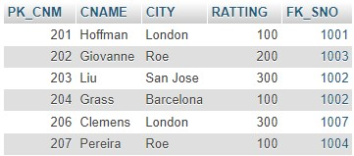

b) Names and cities of all salespeople in London with commission above 0.12

🡪 SELECT SNAME,CITY FROM salseperson WHERE CITY='London' AND COMM>=.12;



c) All salespeople either in Barcelona or in London

🡪 SELECT * FROM salseperson WHERE CITY='London' or CITY='Barcelona';

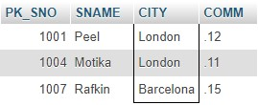

d) All salespeople with commission between 0.10 and 0.12. (Boundary values should be

excluded).

🡪 SELECT * FROM salseperson WHERE COMM BETWEEN 0.10 AND 0.12;

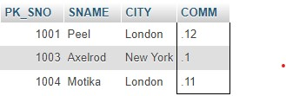

e) All customers excluding those with rating <= 100 unless they are located in Roe

🡪 SELECT * FROM customer WHERE RATTING<=100 OR city='roe';

